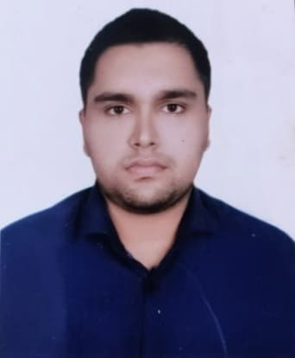**Curriculum Vitae**

**OF**

**Fardin Rahman**

Cell : 01632564443

E-mail : frsshamil@gmail.com

Mailing Address: Biswas Betka Dhaka Road, Tangail Sadar, Tangail-1900

| **Career**  **Objective** | Have a vision to see myself as a highly efficient executive of a dynamic organization where I can utilize my learning, interpersonal skill, analytical ability and adaptability for further development. |
| --- | --- |

|  |
| --- |

| **Academic Background** | 🞖 **Bachelor of Science (B.Sc)**  Institute : Haji Abul Hossain Institute of Technology  Subject : CSE  Result : 3.34  Passing Year : Current Student  University : National University  🞖 **Higher Secondary Certificate (H.S.C)**  Institute : Notre Dame College, Dhaka  Group : Science  Result : GPA-5.00 (Out of 5.00)  Passing Year : 2019  Board : Dhaka  🞖 **Secondary School Certificate (S.S.C)**  Institute : Bindu Basini Govt. Boys High School, Tangail  Group : Science  Result : GPA-5.00 (Out of 5.00)  Passing Year : 2017  Board : Dhaka |
| --- | --- |

| **Programming Skills** | * Python Django |
| --- | --- |

| **Skills &**  **Abilities** | * Adept in communication skill. * Capable of working under pressure. * Able to organize and motivating. * Able to critical problem solving and decision making. * Able to work in a team. * Able to good management. * Able to operate Photoshop & Illustrator. |
| --- | --- |

| **Language**  **Skills** | * Bengali as a mother language. * English as a foreign language. |
| --- | --- |

| **Hobbies & Interest** | * Hard Working. * Traveling and Tourism. * Spending time with computer. * Sports. |
| --- | --- |

| **Personal**  **Details** | * Name : Fardin Rahman * Father’s Name : Moshiur Rahman * Mother’s name : Kaniz Farzana * Date of Birth : 19 January 2002 * Religion : Islam * Marital Status : Unmarried * Blood Group : B+ * NID Number : 5565362463 * Nationality : Bangladeshi (by Birth). |
| --- | --- |

| **Permanent Address** | Village : Biswas Betka  Post Office : Tangail (1900)  Police Station : Tangail  District : Tangail |
| --- | --- |

| **Declaration** | I do hereby declare that all the information disclosed here is correct. |
| --- | --- |

Yours truly

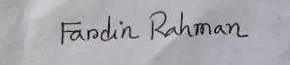.............................

**Fardin Rahman**